**Experiment 09 - *Network Cabling*** (example).

**Objective**

* Connection of Fast Ethernet interface
* Connection of Serial interface
* PC to Router connection

**Theory**

In computer networking, **Fast Ethernet** is a collective term for a number of Ethernet standards that carry traffic at the nominal rate of 100 Mbit/s (the original Ethernet speed was 10 Mbit/s). Of the Fast Ethernet standards, 100BASE-TX is by far the most common.

Fast Ethernet was introduced in 1995 as the IEEE 802.3u standard and remained the fastest version of Ethernet for three years before it was superseded by the Gigabit Ethernet.

In telecommunication and computer science, **serial communication** is the process of sending data one bit at a time, sequentially, over a communication channel or computer bus. This is in contrast to parallel communication, where several bits are sent as a whole, on a link with several parallel channels.

A **router** is a device that forwards data packets along networks. A router is connected to at least two networks, commonly two LANs or WANs or a LAN and its ISP's network. Routers are located at gateways, the places where two or more networks connect.

**Networking cables** are networking hardware used to connect one network device to other network devices or to connect two or more computers to share printer, scanner etc. Different types of network cables like Coaxial cable, Optical fiber cable, Twisted Pair cables are used depending on the network's topology, protocol and size. The devices can be separated by a few meters (e.g. via Ethernet) or nearly unlimited distances (e.g. via the interconnections of the Internet).

**Tools**

* Cisco Packet Tracer
* End devices(3 PCs).
* Routers(4 pieces).
* Connections(Copper Cross-Over).
* Connections(Serial DTE).

**Procedure**

* We take 3 PCs and 4 Routers.
* For each router we enable two serial ports because serial ports are not enabled by default.
* Now we configure each of the routers for serial interface by command line interface CLI. We have used the following commands here -

For **router0**

Router>en

Router#conf t

Router(config)#interface serial 0/0/0

Router(config-if)#ip add 192.168.1.1 255.255.255.0

Router(config-if)#clock rate 64000

Router(config-if)#no shut

Router(config-if)#exit

Router(config)#interface serial 0/0/1

Router(config-if)#ip add 192.168.2.1 255.255.255.0

Router(config-if)#clock rate 64000

Router(config-if)#no shut

Router(config-if)#exit

Router(config)#interface serial 0/1/0

Router(config-if)#ip add 192.168.4.2 255.255.255.0

Router(config-if)#clock rate 64000

Router(config-if)#no shut

Router(config-if)#exit

For **router1**

Router>en

Router#conf t

Router(config)#interface serial 0/0/0

Router(config-if)#ip add 192.168.1.2 255.255.255.0

Router(config-if)#clock rate 64000

Router(config-if)#no shut

Router(config-if)#exit

Router(config)#interface serial 0/0/1

Router(config-if)#ip add 192.168.3.2 255.255.255.0

Router(config-if)#clock rate 64000

Router(config-if)#no shut

Router(config-if)#exit

Router(config)#interface serial 0/1/0

Router(config-if)#ip add 192.168.5.2 255.255.255.0

Router(config-if)#clock rate 64000

Router(config-if)#no shut

Router(config-if)#exit

For **router2**

Router>en

Router#conf t

Router(config)#interface serial 0/0/0

Router(config-if)#ip add 192.168.2.2 255.255.255.0

Router(config-if)#clock rate 64000

Router(config-if)#no shut

Router(config-if)#exit

Router(config)#interface serial 0/0/1

Router(config-if)#ip add 192.168.3.1 255.255.255.0

Router(config-if)#clock rate 64000

Router(config-if)#no shut

Router(config-if)#exit

Router(config)#interface serial 0/1/0

Router(config-if)#ip add 192.168.6.2 255.255.255.0

Router(config-if)#clock rate 64000

Router(config-if)#no shut

Router(config-if)#exit

For **router2**

Router>en

Router#conf t

Router(config)#interface serial 0/0/0

Router(config-if)#ip add 192.168.4.1 255.255.255.0

Router(config-if)#clock rate 64000

Router(config-if)#no shut

Router(config-if)#exit

Router(config)#interface serial 0/0/1

Router(config-if)#ip add 192.168.5.1 255.255.255.0

Router(config-if)#clock rate 64000

Router(config-if)#no shut

Router(config-if)#exit

Router(config)#interface serial 0/1/0

Router(config-if)#ip add 192.168.6.1 255.255.255.0

Router(config-if)#clock rate 64000

Router(config-if)#no shut

Router(config-if)#exit

* Now we create connections among the routers using serial DTE

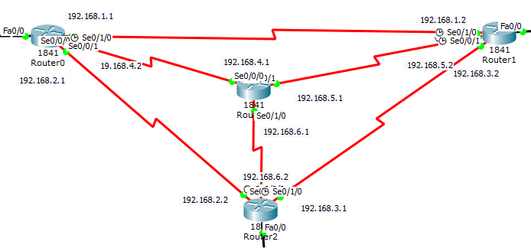

* At this step we will create fast ethernet connections by following commands -

For **router0**

Router(config)#int fa 0/0

Router(config-if)#ip add 192.168.7.1 255.255.255.0

Router(config-if)#no shut

Router(config-if)#exit

For **router1**

Router(config)#int fa 0/0

Router(config-if)#ip add 192.168.8.1 255.255.255.0

Router(config-if)#no shut

Router(config-if)#exit

For **router2**

Router(config)#int fa 0/0

Router(config-if)#ip add 192.168.9.1 255.255.255.0

Router(config-if)#no shut

Router(config-if)#exit

* Now we connect the PCs with the routers using fast ethernet port with copper cross-over cable.

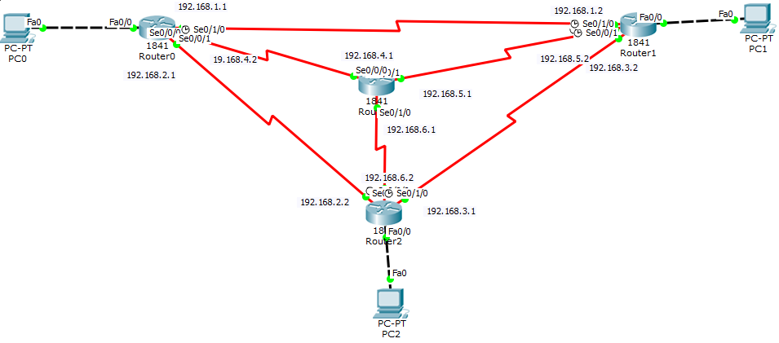

* We give respective IP configuration to each of the PCs

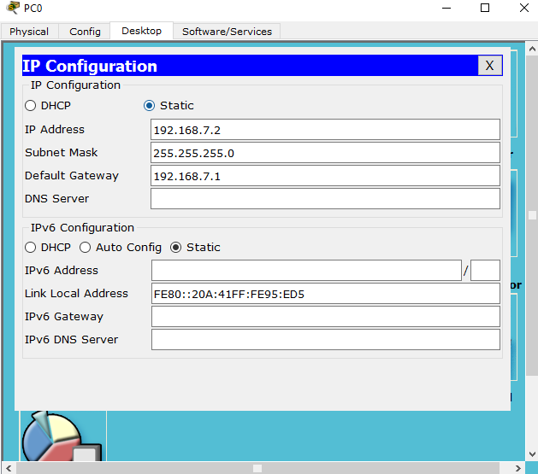

* Now we define open shortest path first for each of the routers.

For **router0**

Router(config)#router ospf 1

Router(config-router)#network 192.168.1.0 0.0.0.255 area 0

Router(config-router)#network 192.168.2.0 0.0.0.255 area 0

Router(config-router)#network 192.168.4.0 0.0.0.255 area 0

Router(config-router)# exit

For **router1**

Router(config)#router ospf 1

Router(config-router)#network 192.168.1.0 0.0.0.255 area 0

Router(config-router)#network 192.168.3.0 0.0.0.255 area 0

Router(config-router)#network 192.168.5.0 0.0.0.255 area 0

Router(config-router)# exit

For **router2**

Router(config)#router ospf 1

Router(config-router)#network 192.168.2.0 0.0.0.255 area 0

Router(config-router)#network 192.168.3.0 0.0.0.255 area 0

Router(config-router)#network 192.168.6.0 0.0.0.255 area 0

Router(config-router)# exit

For **router3**

Router(config)#router ospf 1

Router(config-router)#network 192.168.4.0 0.0.0.255 area 0

Router(config-router)#network 192.168.5.0 0.0.0.255 area 0

Router(config-router)#network 192.168.6.0 0.0.0.255 area 0

Router(config-router)# exit

**Simulation**

Our connection has completed. Now we simulate the connections by sending messages between PCs. Successful message passing defines successful connections.

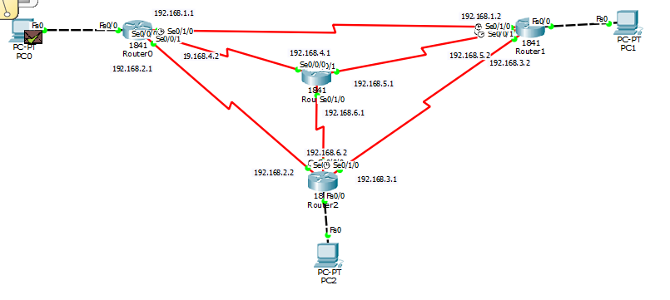

**Conclusion**

We have successfully created a network using fast ethernet and serial interface connection. We have checked the commands for routers carefully so that none of the IP addresses them didn’t overlap. A successful simulation verified the network.